**Corestack Offboarding Steps:**

1. **Offboard Stack from the main account:**

To offboard the Corestack from the main account, Go to **the Cloudformation 🡪 stacks**, find the corestack deployed stack, and **delete**

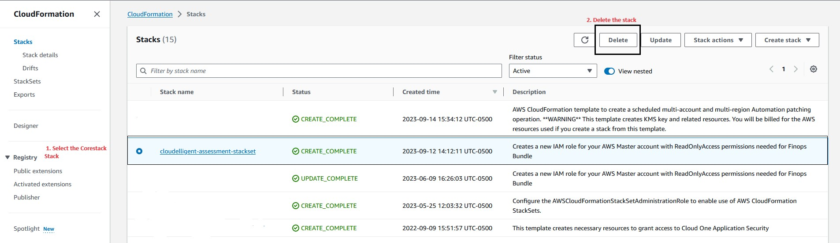

1. **Offboard stack from the linked account**:
2. To offboard the corestack from the main account, Go to **the Cloudformation 🡪 stacksSet**, find the corestack deployed stack, and **Delete Stack From Stackset** in the **Action menu.**

b. Type the Root OU ID from the AWS Organization and select the region where the stack is deployed.

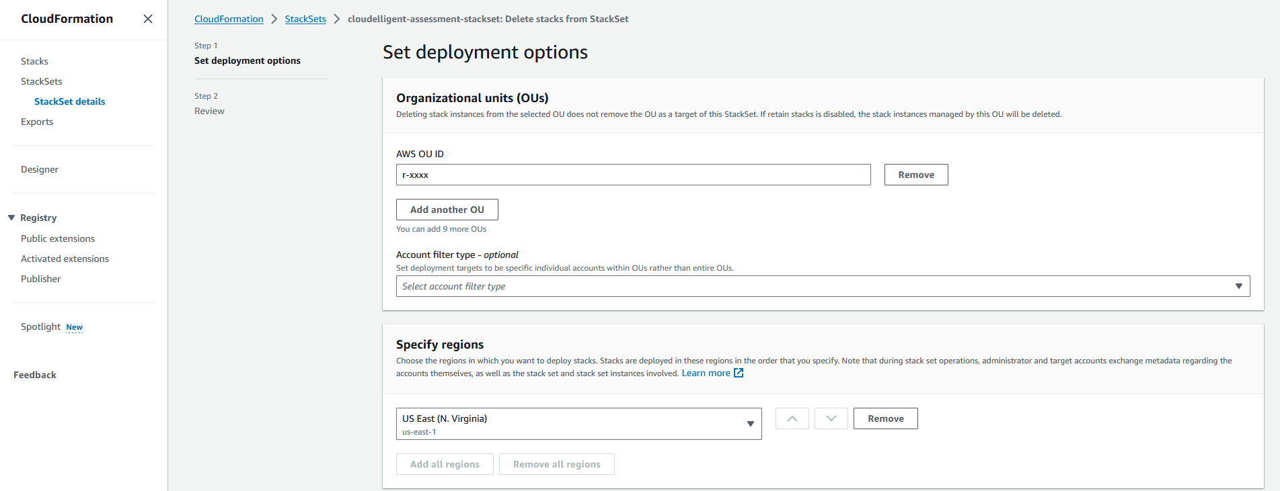

1. Wait until the Stack instance tab gets empty.

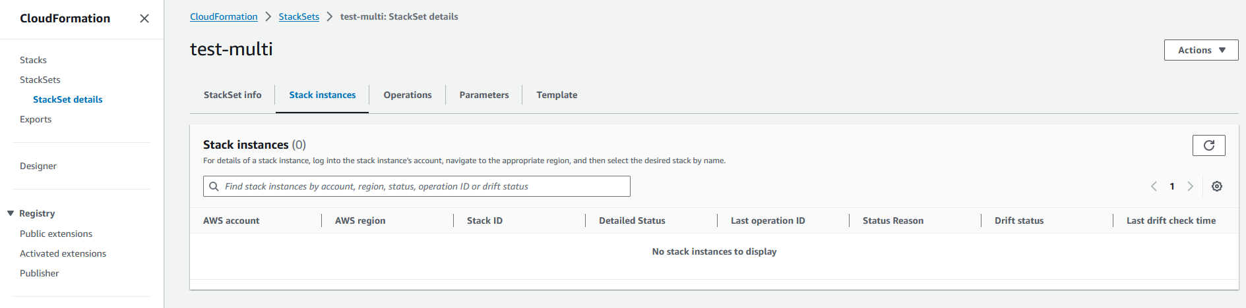

1. Now return back to the StackSet Console Select the Stack and **Delete StackSet** from the **Action** Menu

